**Tugas Kelompok Analisis Algoritma**



Disusun Oleh :

Victor Wijaya - 140810170057

# PROGRAM STUDI TEKNIK INFORMATIKA FAKULTAS MATEMATIKA DAN ILMU PENGETAHUAN ALAM

**UNIVERSITAS PADJADJARAN 2019**

1. **Program Adjacency Matrix dari Undirected Graph Program :**

/*

* C++ Program to Implement Adjacency Matrix

*/

#include <iostream> #include <cstdlib> using namespace std; #define MAX 20

/*

* Adjacency Matrix Class

*/

class AdjacencyMatrix

{

private:

int n;

int **adj; bool *visited;

public:

AdjacencyMatrix(int n)

{

this->n = n;

visited = new bool [n]; adj = new int* [n];

for (int i = 0; i < n; i++)

{

adj[i] = new int [n]; for(int j = 0; j < n; j++)

{

adj[i][j] = 0;

}

}

}

/*

* Adding Edge to Graph

*/

void add_edge(int origin, int destin)

{

if( origin > n || destin > n || origin < 0 || destin < 0)

{

cout<<"Invalid edge!\n";

}

else

{

adj[origin - 1][destin - 1] = 1;

}

}

/*

* Print the graph

*/

void display()

{

int i,j;

for(i = 0;i < n;i++)

{

for(j = 0; j < n; j++) cout<<adj[i][j]<<" ";

cout<<endl;

}

}

};

/*

* Main

*/

int main()

{

int nodes, max_edges, origin, destin; cout<<"Enter number of nodes: "; cin>>nodes;

AdjacencyMatrix am(nodes); max_edges = nodes * (nodes - 1); for (int i = 0; i < max_edges; i++)

{

cout<<"Enter edge (-1 -1 to exit): "; cin>>origin>>destin;

if((origin == -1) && (destin == -1)) break;

am.add_edge(origin, destin);

}

am.display(); return 0;

}

# Output :

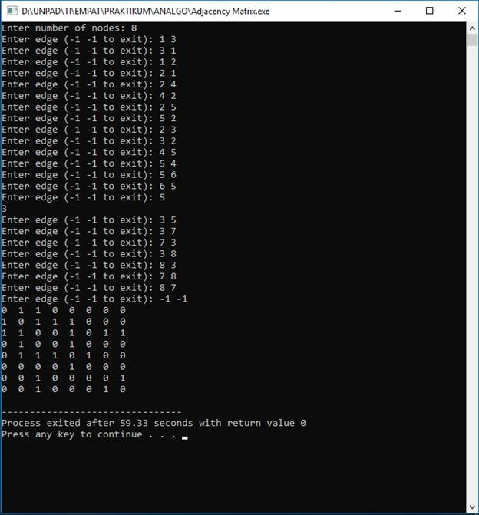

1. **Adjacency List dari Undirected Graph**

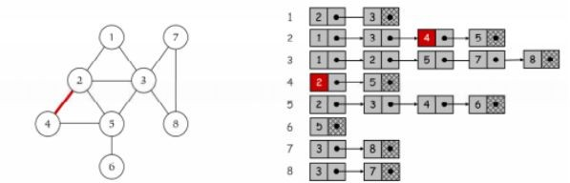

**Program :**

/*

* C++ Program to Implement Adjacency List

*/

#include <iostream> #include <cstdlib> using namespace std;

/*

* Adjacency List Node

*/

struct AdjListNode

{

int dest;

struct AdjListNode* next;

};

/*

* Adjacency List

*/

struct AdjList

{

struct AdjListNode *head;

};

/*

* Class Graph

*/

class Graph

{

private:

int V;

struct AdjList* array; public:

Graph(int V)

{

this->V = V;

array = new AdjList [V]; for (int i = 0; i < V; ++i) array[i].head = NULL;

}

/*

* Creating New Adjacency List Node

*/

AdjListNode* newAdjListNode(int dest)

{

AdjListNode* newNode = new AdjListNode; newNode->dest = dest;

newNode->next = NULL; return newNode;

}

/*

* Adding Edge to Graph

*/

void addEdge(int src, int dest)

{

AdjListNode* newNode = newAdjListNode(dest); newNode->next = array[src].head;

array[src].head = newNode; newNode = newAdjListNode(src); newNode->next = array[dest].head; array[dest].head = newNode;

}

/*

* Print the graph

*/

void printGraph()

{

int v;

for (v = 1; v <= V; ++v)

{

AdjListNode* pCrawl = array[v].head;

cout<<"\n Adjacency list of vertex "<<v<<"\n head "; while (pCrawl)

{

cout<<"-> "<<pCrawl->dest; pCrawl = pCrawl->next;

}

cout<<endl;

}

}

};

/*

* Main

*/

int main()

{

Graph gh(8); gh.addEdge(1, 2);

gh.addEdge(1, 3);

gh.addEdge(2, 4);

gh.addEdge(2, 5);

gh.addEdge(2, 3);

gh.addEdge(3, 7);

gh.addEdge(3, 8);

gh.addEdge(4, 5);

gh.addEdge(5, 3);

gh.addEdge(5, 6);

gh.addEdge(7, 8);

// print the adjacency list representation of the above graph gh.printGraph();

return 0;

}

# Output :

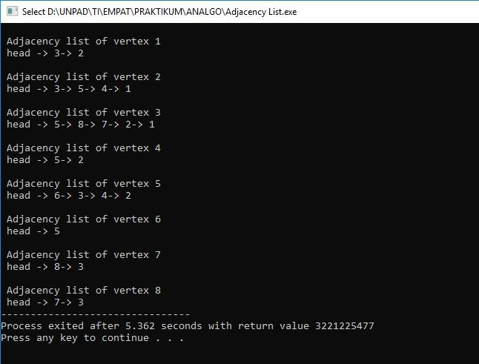

1. **Program BFS dari Undirected Graph**

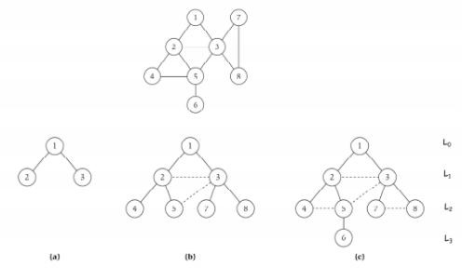

**Program :**

// Program to print BFS traversal from a given

// source vertex. BFS(int s) traverses vertices

// reachable from s. #include<iostream> #include <list>

using namespace std;

// This class represents a directed graph using

// adjacency list representation class Graph

{

int V; // No. of vertices

public:

};

// Pointer to an array containing adjacency

// lists list<int> *adj;

Graph(int V); // Constructor

// function to add an edge to graph void addEdge(int v, int w);

// prints BFS traversal from a given source s void BFS(int s);

Graph::Graph(int V)

{

this->V = V;

adj = new list<int>[V];

}

void Graph::addEdge(int v, int w)

{

adj[v].push_back(w); // Add w to v’s list.

}

void Graph::BFS(int s)

{

// Mark all the vertices as not visited bool *visited = new bool[V];

for(int i = 0; i < V; i++)

visited[i] = false;

// Create a queue for BFS list<int> queue;

// Mark the current node as visited and enqueue it visited[s] = true;

queue.push_back(s);

// 'i' will be used to get all adjacent

// vertices of a vertex list<int>::iterator i;

while(!queue.empty())

{

// Dequeue a vertex from queue and print it s = queue.front();

cout << s << " "; queue.pop_front();

// Get all adjacent vertices of the dequeued

// vertex s. If a adjacent has not been visited,

// then mark it visited and enqueue it

for (i = adj[s].begin(); i != adj[s].end(); ++i)

{

if (!visited[*i])

{

visited[*i] = true; queue.push_back(*i);

}

}

}

}

// Driver program to test methods of graph class int main()

{

// Create a graph given in the above diagram Graph g(8);

g.addEdge(1, 2);

g.addEdge(1, 3);

g.addEdge(2, 4);

g.addEdge(2, 5);

g.addEdge(2, 3);

g.addEdge(3, 7);

g.addEdge(3, 8);

g.addEdge(4, 5);

g.addEdge(5, 3);

g.addEdge(5, 6);

g.addEdge(7, 8);

cout << "Following is Breadth First Traversal "

<< "(starting from vertex 1) \n"; g.BFS(1);

return 0;

}

# Output :

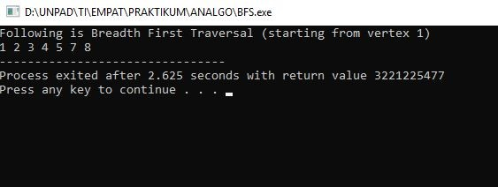

Karena Big-O dari BFS adalah O(V+E) dimana V itu jumlah vector dan E itu adalah jumlah edges maka Big-O = O(n) dimana n = v+e

Maka dari itu Big-Ө nya adalah Ө(n).

# Program DFS undirected Graph

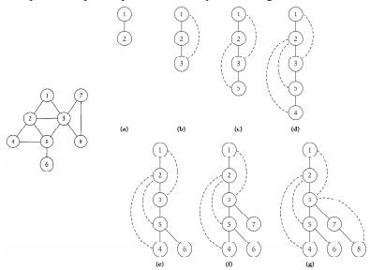

**Program**

**// C++ program to print DFS traversal from**

**// a given vertex in a given graph #include<iostream>**

**#include<list>**

**using namespace std;**

**// Graph class represents a directed graph**

**// using adjacency list representation class Graph**

**{**

**int V; // No. of vertices**

**// Pointer to an array containing**

**// adjacency lists list<int> *adj;**

**// A recursive function used by DFS void DFSUtil(int v, bool visited[]);**

**public:**

**Graph(int V); // Constructor**

**// function to add an edge to graph void addEdge(int v, int w);**

**// DFS traversal of the vertices**

**// reachable from v void DFS(int v);**

**};**

**Graph::Graph(int V)**

**{**

**this->V = V;**

**adj = new list<int>[V];**

**}**

**void Graph::addEdge(int v, int w)**

**{**

**adj[v].push_back(w); // Add w to v’s list.**

**}**

**void Graph::DFSUtil(int v, bool visited[])**

**{**

**// Mark the current node as visited and**

**// print it visited[v] = true; cout << v << " ";**

**// Recur for all the vertices adjacent**

**// to this vertex list<int>::iterator i;**

**for (i = adj[v].begin(); i != adj[v].end(); ++i) if (!visited[*i])**

**DFSUtil(*i, visited);**

**}**

**// DFS traversal of the vertices reachable from v.**

**// It uses recursive DFSUtil() void Graph::DFS(int v)**

**{**

**// Mark all the vertices as not visited bool *visited = new bool[V];**

**for (int i = 0; i < V; i++) visited[i] = false;**

**// Call the recursive helper function**

**// to print DFS traversal**

**DFSUtil(v, visited);**

**}**

**int main()**

**{**

**// Create a graph given in the above diagram Graph g(8);**

**g.addEdge(1, 2);**

**g.addEdge(1, 3);**

**g.addEdge(2, 4);**

**g.addEdge(2, 5);**

**g.addEdge(2, 3);**

**g.addEdge(3, 7);**

**g.addEdge(3, 8);**

**g.addEdge(4, 5);**

**g.addEdge(5, 3);**

**g.addEdge(5, 6);**

**g.addEdge(7, 8);**

**cout << "Following is Depth First Traversal" " (starting from vertex 1) \n";**

**g.DFS(1);**

**return 0;**

**}**

